Wizard of Oz Video Mod Installation

Important: Please read all instructions before beginning the installation of your new pinball mod. Pixels, LLC is not responsible for any damage caused by improper installation or user error. Each pinball mod is covered under a limited warranty.

Please note: There are several wiring variations for the Wizard of Oz pinball machine. Wire colors have changed and some machines now have three pin connectors. This mod was designed for use in the two pin models.

Additionally, this video mod will not work with the Yellow Brick Road version without alteration. If you choose to alter this mod to fit this version, Pixels, LLC is in no way liable for any damage to the mod or the machine.

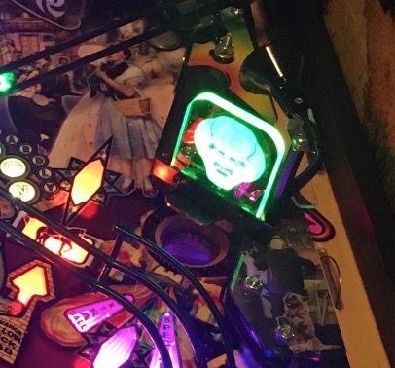
1. The Woz video mod will be placed where the glowing head currently sits, toward the right front side of the machine. Shown below.

2. Remove the glowing head and the electrical associated with it.

3. Loosen and remove the post the spotlight sits on (behind the head). Do not remove the spotlight, as it stays in the game.

Please note: The removal of the post is optional. It will serve no purpose for the newly installed video mod. However, the metal post cannot touch the back of the mod. It will cause a short.

4. On the back of the Woz video mod there is a tab with a hole in it. Place the tab over the screw that is sticking up where the spotlight used to be. There is flexibility in Woz video placement, however, this location is our recommendation.

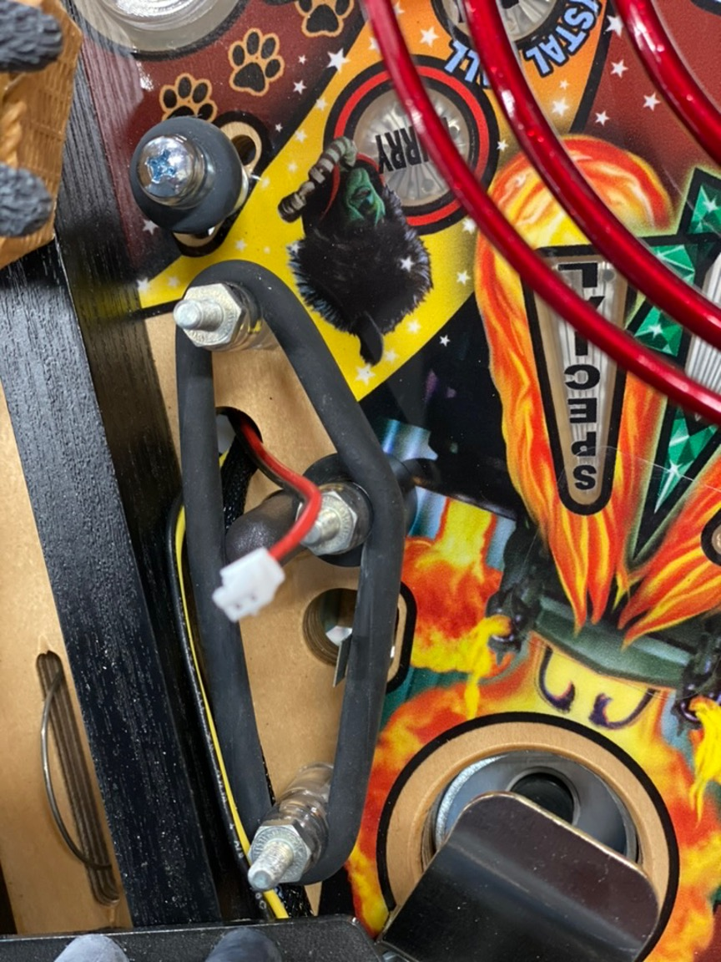
5. You may need to loosen the wizard plastic below (where the glowing head used to be) to allow enough space to feed the video mod wires through. You will feed the video mod wires from the bottom to the top of the playfield, so you will need to lift the playfield. Feed the wires for the video mod through the same hole the glowing head wires were removed from. Shown below.

6. Attach the small connector (shown above) to your video mod. Then replace the wizard plastic.

IMPORTANT: DO NOT CONNECT THIS VIDEO MOD TO ANY VOLTAGE OVER 7.5! It will cause damage to the mod and will NOT be covered under the warranty. The adapter can be connected to any lower voltage line that runs the LED lights. We recommend using a volt meter to ensure the connection is 7.5V or lower.

7. This kit comes with an adapter to connect your mod. Shown below. The connectors have not been wired on purpose to be adapted to your machine’s wiring connections. Ensure the polarity is correct to match your machine before inserting the adapter wires into the (included) connectors. Once the wires are inserted, they are very difficult to remove.

To install the wires into the connector, simply click the wires into the white connectors. Again, before completing this step, ensure the wires are aligned with the correct wire connection on your machine, i.e. hot and ground. You will need to lift the playfield and locate this connection. This is outlined in Step 6.

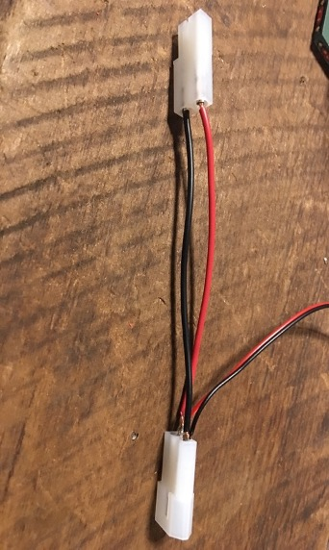
Please note: There is an additional male connector included to allow the wires to fit snuggly into the female connector in the machine. The female connector (included) will fit with just about any male connector on your machine.

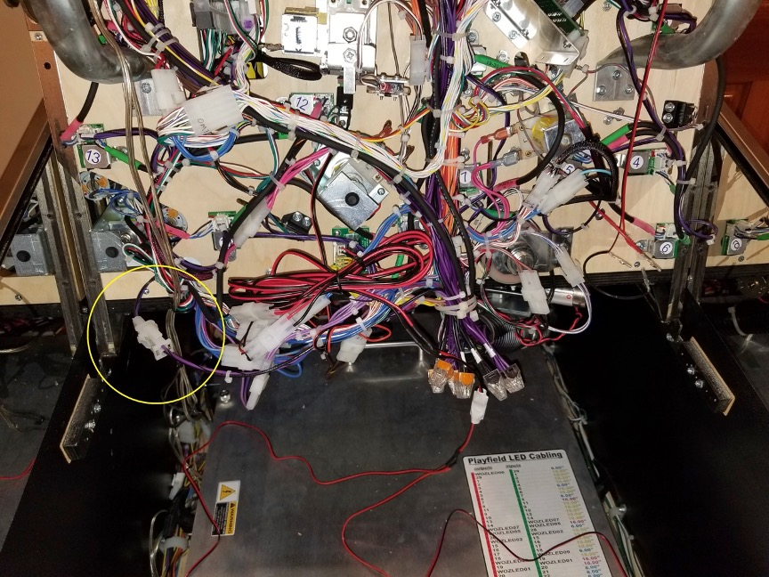
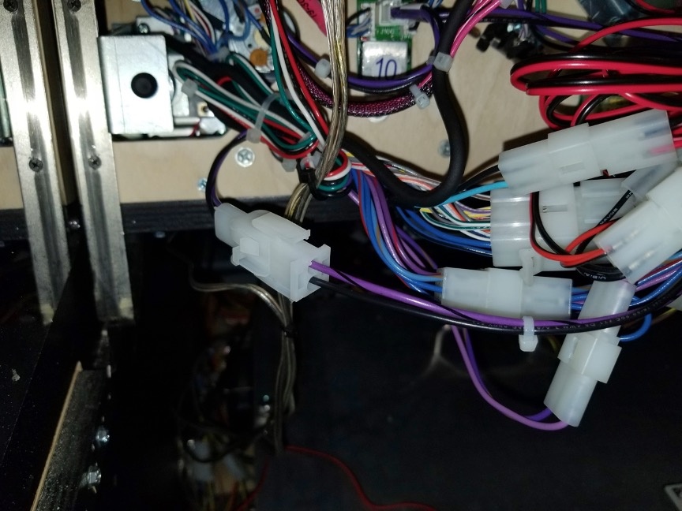
8. Locate the connector, as shown circled below. It should have one wire that is purple with a black stripe, and one wire that is solid black (also shown below). This connector will be located on the main wiring loom, midway down the playfield, or all the way at the bottom when the playfield is lifted. The wiring kit for this mod will be attached between the female and male connector in your machine.

9. The male plug (provided for this mod) will attach to the female plug on your machine. The female plug (provided for this mod) will attach to the male plug on your machine. The purple and black striped wire should be connected to the red wire (HOT) and the black wires should be connected together (GROUND).
10. Turn on your pinball machine and enjoy!

Thank you for your purchase!
Pixels, LLC is a Veteran owned family business and we appreciate your support!

All of our pinball mods are handmade and tested in our very own pinball machines. If you should encounter any issues, please let us know and we will do our best to make it right!

Additionally, if you should have any questions or suggestions on how we can improve our products, we would love to hear from you!

info@pixelsarcadegames.com

