**Lightsaber Mod Instructions**

1. Turn off your machine. We are not responsible for electrical damage or injury caused from installing our mods. If you need help or are not familiar with installing mods or pinball machine electronics consult a professional.
2. Locate where the mod connects.

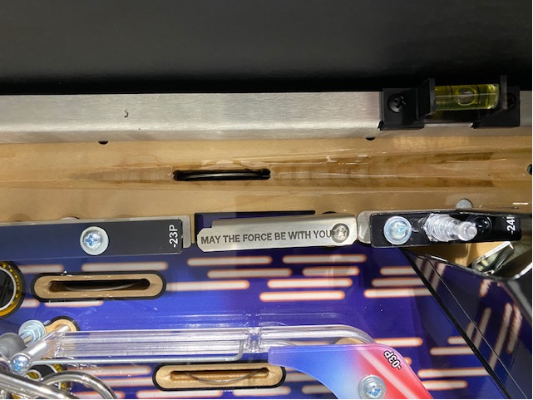

1. Feed the wire through the skirt as shown and then through the hole in the playfield below the skirt. You should not need to remove the skirt to accomplish this.

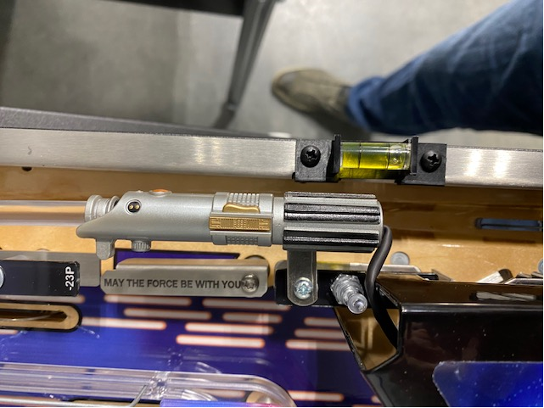

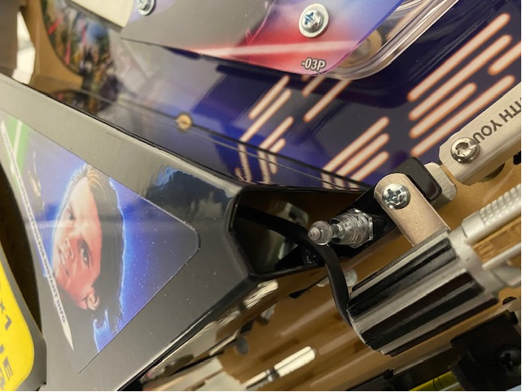

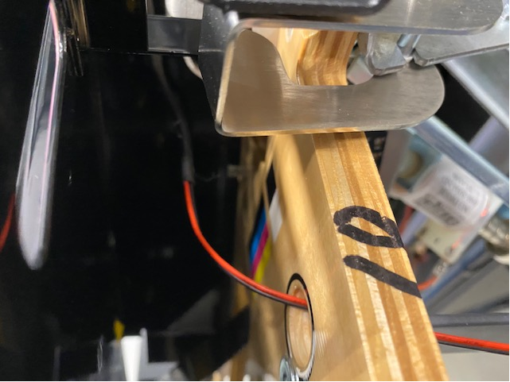

1. Connect clips as shown

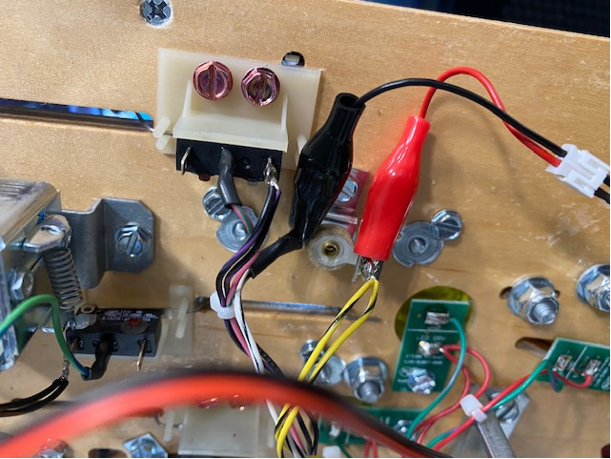

1. Secure to the post.

