**Installation Instructions Woz Video Mod**

**Thanks very much for purchasing this mod from me. The installation of this is somewhat involved. To start with I would suggest turning off the power to the game. We are not responsible for any damage caused from installing this mod. I have come across about 3 different types of wiring configurations for this game. Parts included will allow you to connect to any machine.**

1. **The mod goes where the big green glowing head is on the right hand side of your game.**

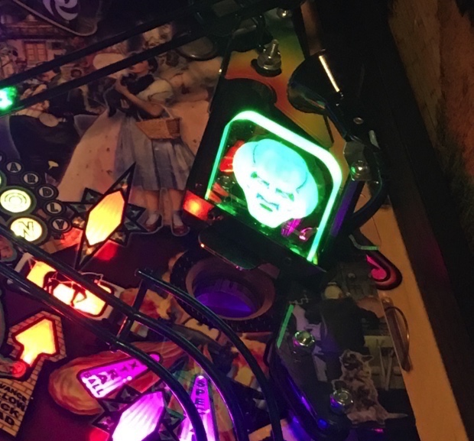

1. **You will need to remove the glowing head and all of the electrical that goes with it. Also, loosen and remove the post that the spotlight sits on top of behind the head. Do not unwire this, it stays in the game.**
2. **On the back of the mod you will notice a tab with a hole in it. You will be placing that tab over the screw that is sticking up where the spot light was.**
3. **You will probably need to loosen the wizard plastic that is below the head to feed the wires through. You will want to feed the wires for the mod through where the wires for the old head came out of.**
4. **THIS IS IMPORTANT. DO NOT CONNECT THIS TO ANYTHING OVER 7.5V you will cook it. If you damage the mod from voltage it is not convered by warranty. Has to be connected to the lower voltage side that runs your lights. I hooked mine up to shown in #7 below. You may find this toward the bottom of the playfield when you have it tilted up or there may be one in the wiring loom with nothing connected to in depending on the model you have and year. You can connect it to any line that runs the leds in the game. I would suggest using a volt meter to check it. Anything 7.5v or below is ok.**
5. **The kit comes with an adapter to connect your mod. (Below right) The connectors are not wired on purpose so you can choose which end the female and male ends go on to match the connector you are using. Just be sure the polarity is right to match your game. There is an additional male connector that will allow you to fit snugly into the female connector on your game. The female connector I sent will work with just about any male plug on any game. Just simply click the wires into the white connectors. Just be sure that you get the wires in the right connector. They are very hard to get out once in.**
6. **You want to find a connector like the one below (figure a and b) that is purple with a black stripe and black. What I have found is that this game has various types of wiring. Your wire may not be purple and black. This connector will be located either off of the main wiring loom about midway down the playfield or all the way at the bottom when tilted up. The wire kit included will go between the female and male connector in your game.**

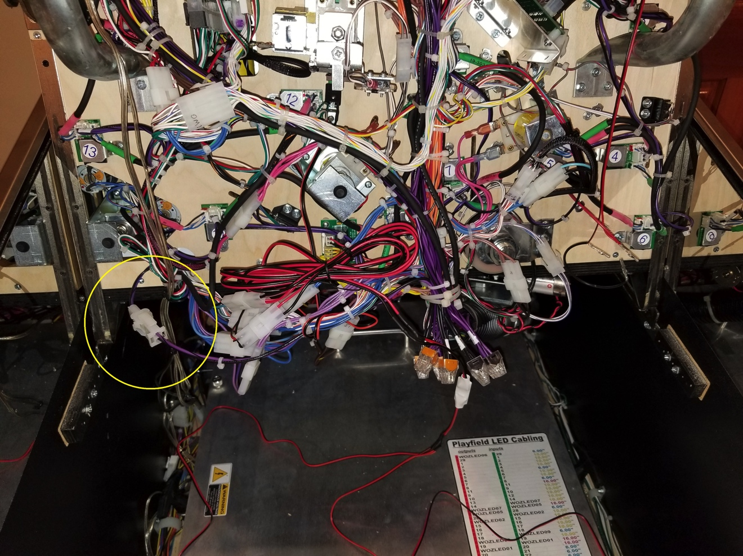

**FIGURE “A”**

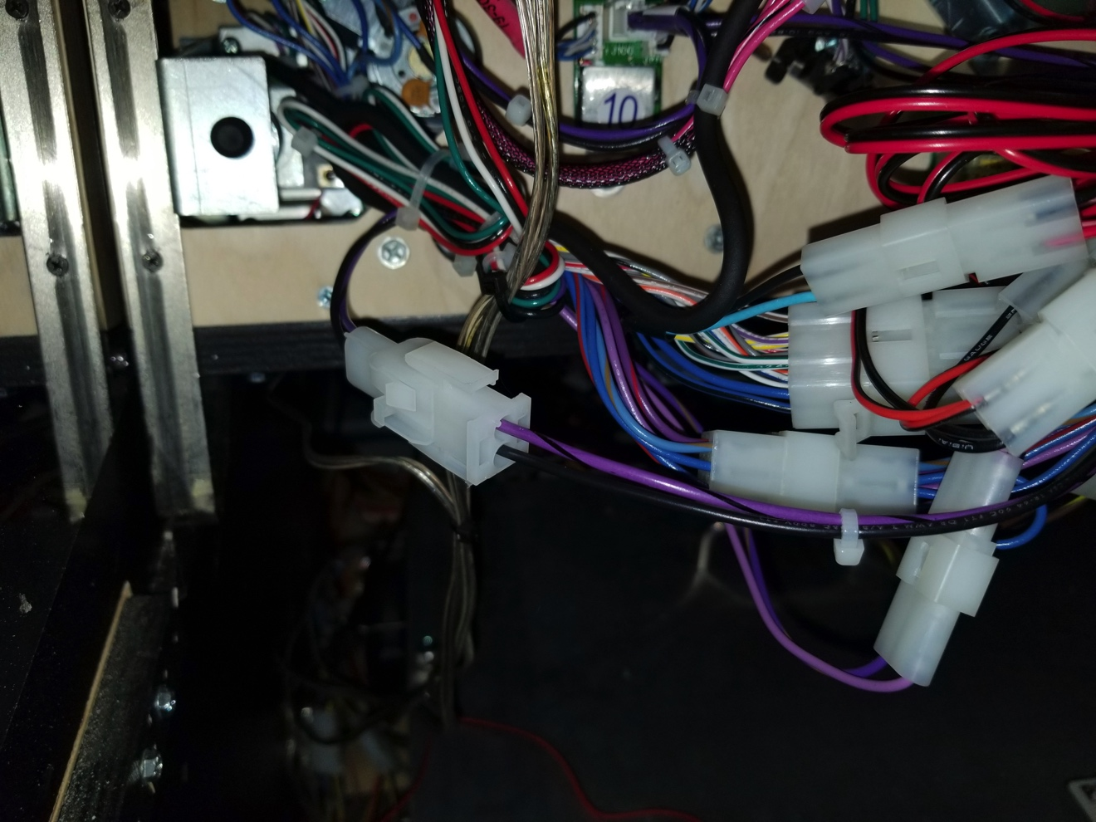

**FIGURE “B”**

1. **You will plug the male plug provided into the female plug on your game (FIGURE C). The Female end of your plug will be connected to the male plug on your game. The purple and black wire should be connected to the red wire (Hot). Black is ground.**

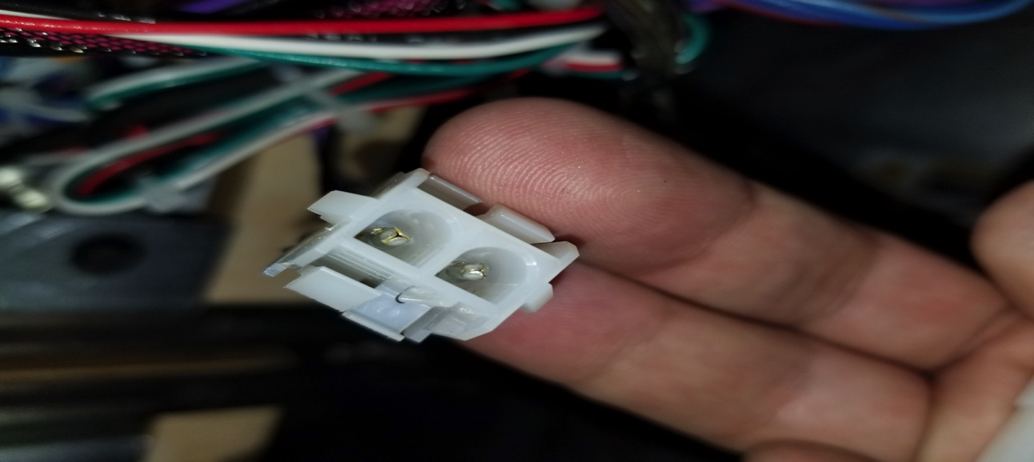

**FIGURE “C”**

1. **Finally, connect your mod to the wire on the adapter after it is connected to the game. Turn your machine on and your mod should come to life. Turn the machine back off and secure the mod to the playfield. You have a few options here. You can secure it to any of the posts that holds the wizard plastic on or you can put it below the spotlight post. You can decide that way where you like the positioning.. IF YOU HAVE ANY QUESTIONS OR PROBLEMS, you can email me at info@pixelsarcadegames.com**

**NOTE: It is possible that your game does not have either connector shown below. If that is the case there are two red crimp on connectors that you can use to connect either harness directly to the wires in your game. These are last resort connectors. You can also connect the harness directly to one of the lighting boards ash shown here:**

**10: Should look like this when done.**

