**Installation Instructions For Key to the Lonely Mountain**

This one is pretty easy. First step TURN YOUR MACHINE OFF! We are not responsible for damage to any machine from one of our mods.

The key can go anywhere on the playfield. Ours is on the left side right over the elf targets. You will simply place it on the post and feed the wire down any hole in the playfield to the backside.

Once you get the wire fed through you will connect with the harness provided. The LED is 12 volts so you can connect it to just about any harness in the machine. There are two different molex connectors in the package. Choose the one you wish to use. Keep in mind that unless you have a removal tool once it is in in stays in. Below is an example of one of the connectors you can choose.

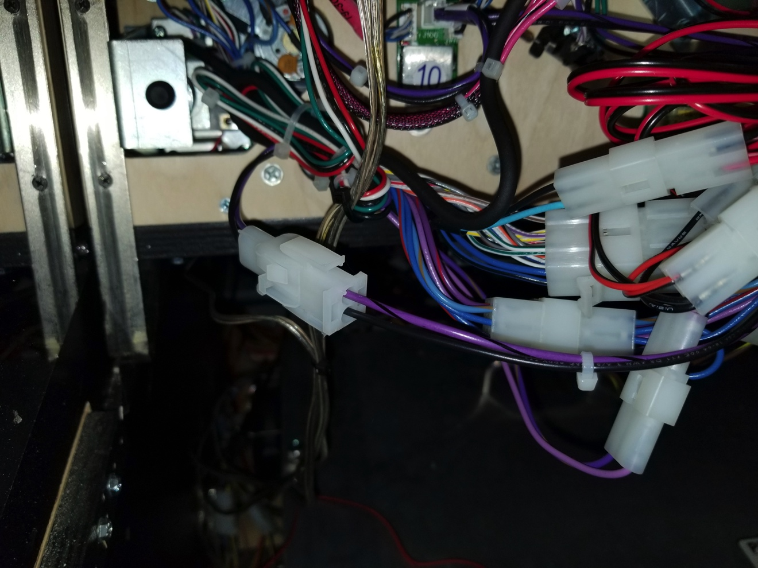

Once connected tidy up the extra wire and turn your machine on. Note, these are hand made. Some may glow differently than others because of the amount of paint used to get the effect of age. If you are not happy please let us know. We will make it right. We are adding a video of the mod be adding video instruction to our site soon. Please check to see if it is available.