**Installation Instructions Emerald City Mod**

**Thanks very much for purchasing our Emerald City Mod. This is a new mod to our collection. These are handmade and there are a lot of lights in each one of these. We value your feedback. If you are at all dissatisfied or have suggestions please send them to:** [**info@pixelsarcadegames.com**](mailto:info@pixelsarcadegames.com)**. We will make it right for you! IMPORTANT: The translucent material used is somewhat fragile. If you drop this on the floor it may break. Also, you can break a spire if you are really rough with it. I have not broken any that I have installed but if you get impatient you may damage the mod.**

**The installation of this is pretty straight forward. To start with I would suggest turning off the power to the game. We are not responsible for any damage caused from installing this mod. I have come across about 3 different types of wiring configurations for this game. Parts included will allow you to connect to any machine.**

1. **This mod will go in the back right hand corner of the machine in the location shown below. The wire will run under the plastic you can see in the bottom right of the picture. There are no holes in the back of this machine to run a wire behind the playfield. Most people don’t want to modify their cabinets, but someone could remove the plastic under the mod and drill a small hole there for the wire to run through and then replace the plastics. The mod is designed to not have to do that but it is an option.**

1. **The mod attaches with a command strip. This allows you to remove it without damaging the back panel of your play field should you choose to remove it. The mod is placed to rest just on top of the clear plastic at the back of the playfield . The command strip holds it in place with no weight being placed on that plastic. After you get the command strip placed on the back of your machine as you like it, you will run the wires under the plastic before attaching the city to the machine.**

1. **The mod is designed to be sitting on top of the clear plastic in the back corner that is held up by the two rubber spacers. You should not have to remove any screws to place this mod. Unless you choose to run the wires a different way. There is a space between that clear plastic and the back of the playfield, just angle the wires down and run them under there as shown below.**

**Simply figure out where you would like the mod to sit. The pictures below shows how the mod rests on that plastic. You can also see how the wire runs under it and then drops down on the side of the playfield.**

1. **The LEDs in the mod will handle up to 12 volts but I would suggest connecting it to one of the lighting connectors in the game shown below. They are well below 12volts but will work great. Unless you want the mod to turn on and off find a connector with constant power. The one shown below meets that need. The kit comes with an adapter to connect your mod. (Below right) The connectors are not wired on purpose so you can choose which end the female and male ends go on to match the connector you are using. Just be sure the polarity is right to match your game. There is an additional male connector that will allow you to fit snugly into the female connector on your game. The female connector I sent will work with just about any male plug on any game. Just simply click the wires into the white connectors. Just be sure that you get the wires in the right connector. They are very hard to get out once in.**

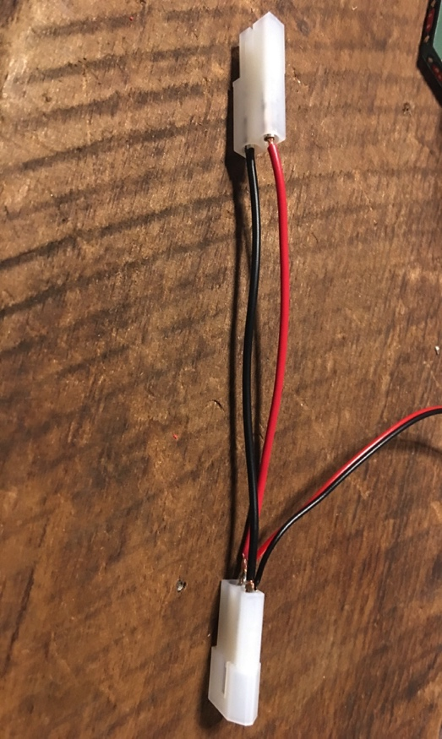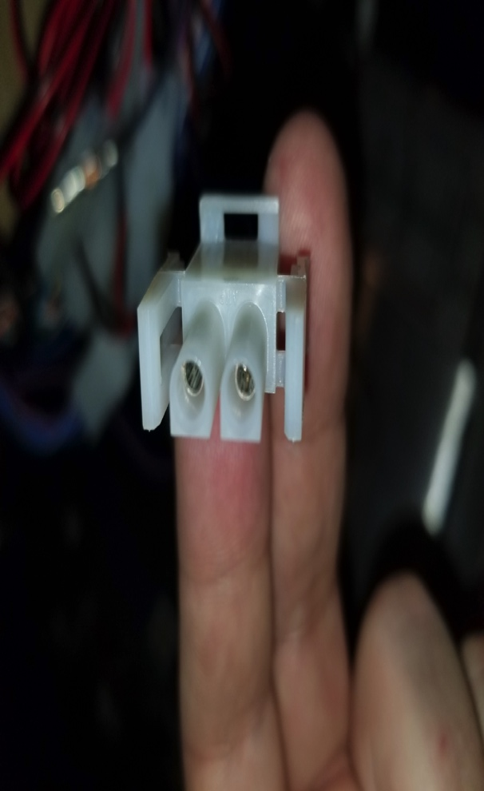

1. **You want to find a connector like the one below (figure a and b) that is purple with a black stripe and black. This connector will be located either off of the main wiring loom about midway down the playfield or all the way at the bottom when tilted up. The wire kit included will go between the female and male connector in your game.**

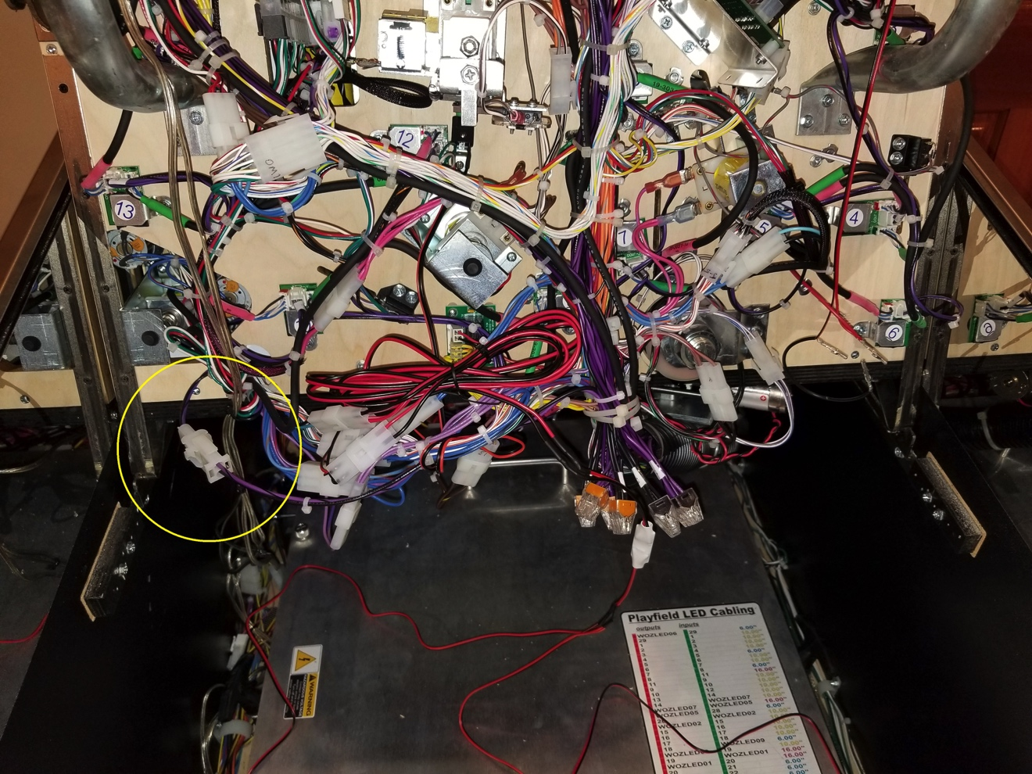

**FIGURE “A”**

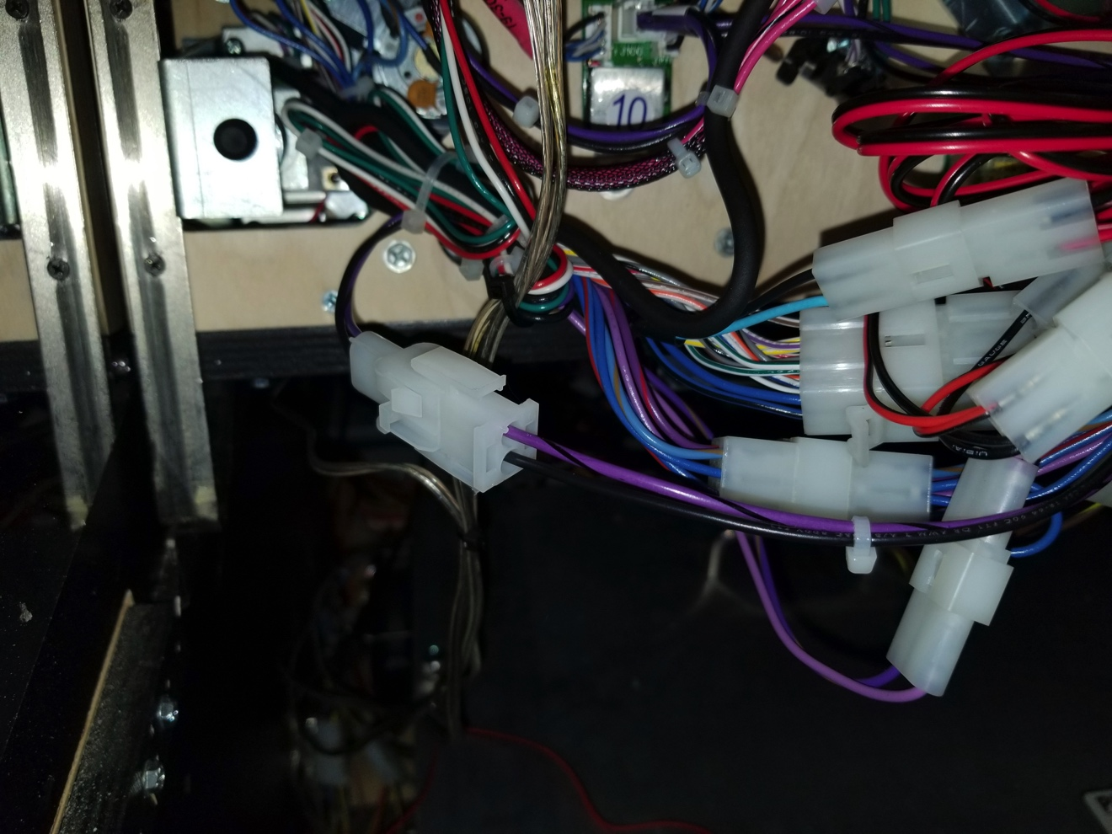

**FIGURE “B-C”**

1. **You will plug the male plug provided into the female plug on your game (FIGURE C). The Female end of your plug will be connected to the male plug on your game. The purple and black wire should be connected to the red wire (Hot). Black is ground.**

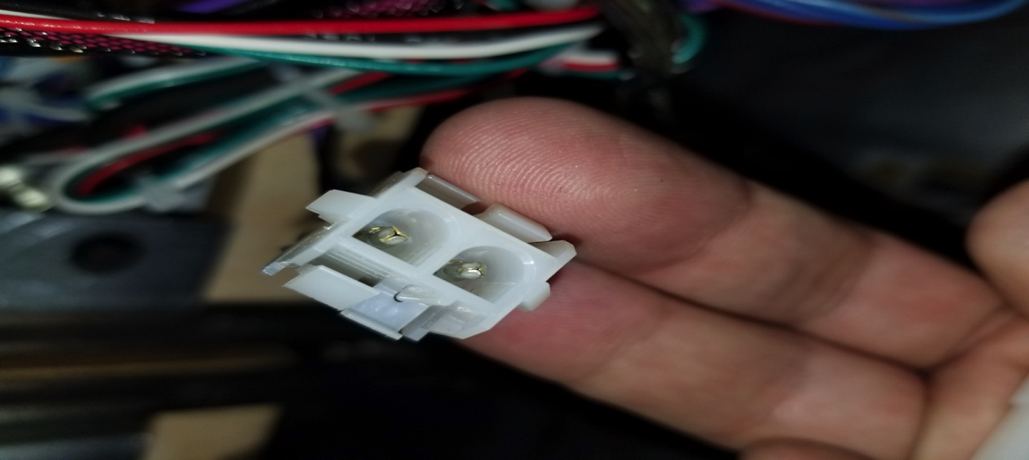

1. **Finally, connect your mod to the wire on the adapter after it is connected to the game. Turn your machine on and your mod should come to life. IF YOU HAVE ANY QUESTIONS OR PROBLEMS, you can email me at info@pixelsarcadegames.com**
2. **When you are done it should look like this:**

