**Throne Installation**

This is a pretty straight forward installation. The throne has a 12V LED so you can plug it into any connector that is 12V or less which covers pretty much all the spots, and light connections in the cabinet. The process these go through to make them look old is extensive. Each one is unique. If you are not happy with it let me know and we can swap it. Put it in your game and see how it looks. Enjoy!

1. Turn your game off! If you choose not to you may blow a fuse while plugging and unplugging wires.
2. Flip up the playfield on your game and find where you would like to connect your mod. You will want to find a connector toward the back and it should look something like this picture. You have a lot of wire to work with so reaching it wont be a problem as long as it is toward the back.

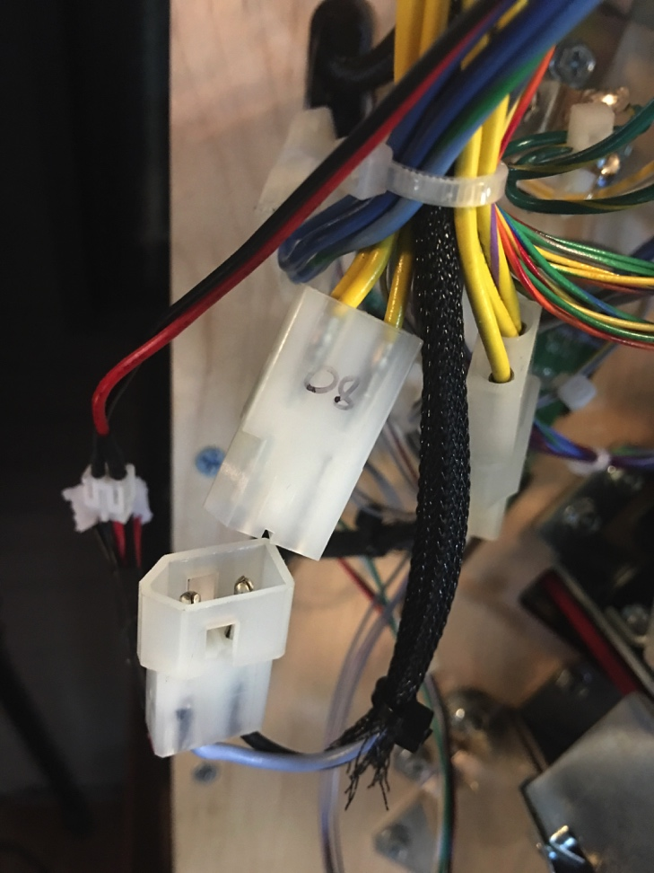

1. In your kit you will notice you have a set of wires and two white connectors. You will want to insert the wires into the connector so that they match up with your wires in your machine. I do not put them in the connectors so if you need to have the female wire in the male connector or the other way around you have maximum flexibility to match up your connector on your game. Here is a picture of how to put the wires in the connectors. PLEASE NOTE: You need to be sure that you put the wires in the connectors so that they match up with the positive and negative terminals on your game. If you don’t the light may not operate. The small wire goes to the mod.

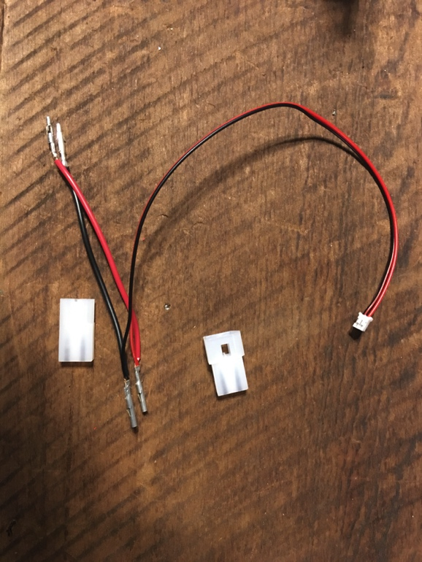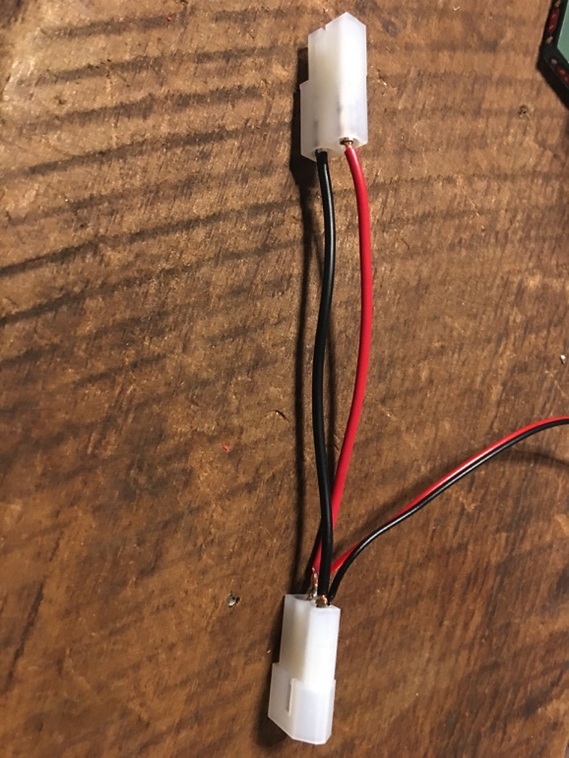

1. Connect the connector to your game. This is a good time to test your mod. You haven’t mounted it and done all that work yet. I test them here so if it doesn’t work something may not be connected correctly. IF it lights up turn the power back off and proceed to the next step.
2. Put the playfield down
3. The location of the throne is right between the two center ramps. You will want to find a location under the plastic toward the back right as you look at the machine to CAREFULLY feed the wire through.

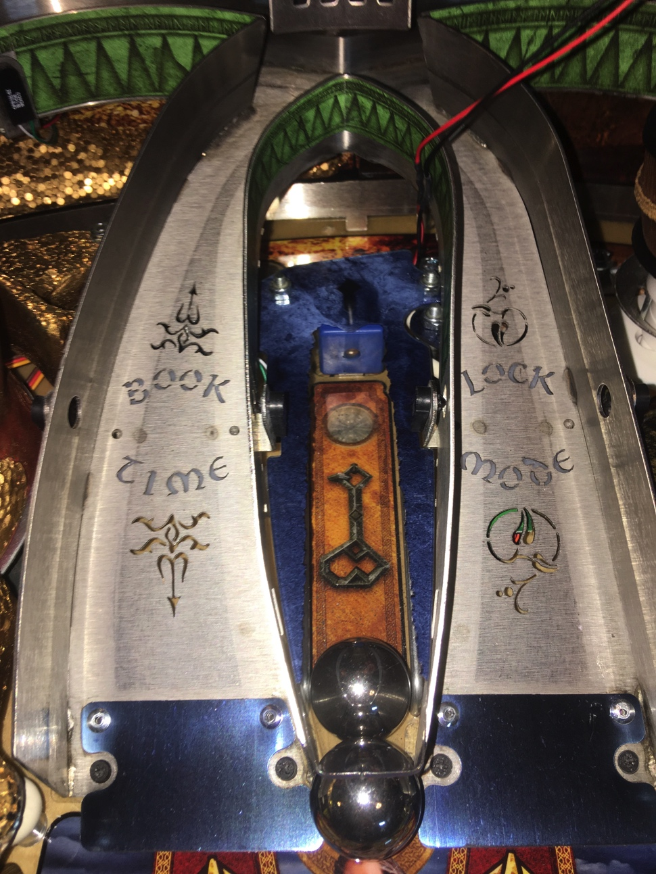

1. Once you have fed the wire through you will want to look for Your connection and plug the mod in.
2. On the bottom of the throne is some mounting tape. Remove the film to stick the throne to the clear plastic between the ramps. You will want to be sure you get it where you want it as it can be very hard to move afterward.
3. After you get the mod attached to the plastic feed the excess wire to the bottom of the machine and zip tie it to a wire bundle under your game.
4. Turn your game on and you should be ready to go!

