**Springfield School Bus Installation**

1. I am not responsible for any damage caused from “user” installing or wiring your mod to your game so please be careful or get someone to assist you with experience.
2. I would suggest turning the power off. It is up to you.
3. Locate where you would like the bus to go. I would suggest as pictured below, the bracket is made for that location but your decision.

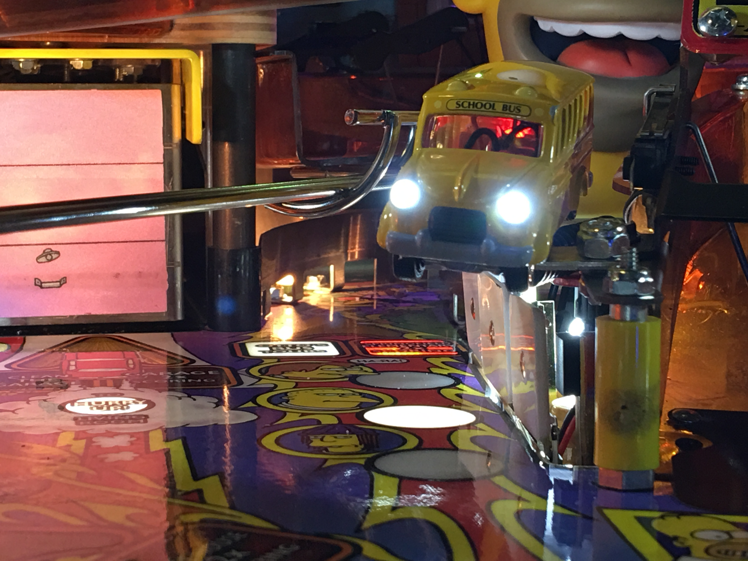

1. Included in the package are two lights with connectors that will allow you to connect the bus to any light in the game. There is also a set of alligator clips if you prefer that method. Finally, there is an additional 36” of cable to allow you to have more flexibility of installation.
2. You will very simply find the best location for you to run your wires to the underside of the playfield and install the connector you prefer. Remove the nut that is shown above to the right of the bus in the picture. Set the bracket to the bus over the threaded screw sticking up and reinstall the nut. That is it.
3. All of these are made by hand, if for any reason you are not happy please let me know so I can try and help you or replace the item. I have tested and installed the bus (your bus) and it looks great in the game but if you aren’t happy please let me know. If you have installation issues please let me know.

Enjoy your bus!!