Installation Instructions

Bar:

1. I am not responsible for any damage caused from “user” installing or wiring your mod to your game so please be careful or get someone to assist you with experience.
2. I would suggest turning the power off. It is up to you.
3. Remove all of the bulbs from where the mod is going to go. (back right corner)
4. Find where you would like the bar to go. There is a black bracket that holds the progress meter that is right behind the TV. The Bar should butt right up against that not over it. Be sure that you do not cover any of the light sockets with the mod. (You can trim the bottom of the mod further if needed in the back if it is too tight for your liking)

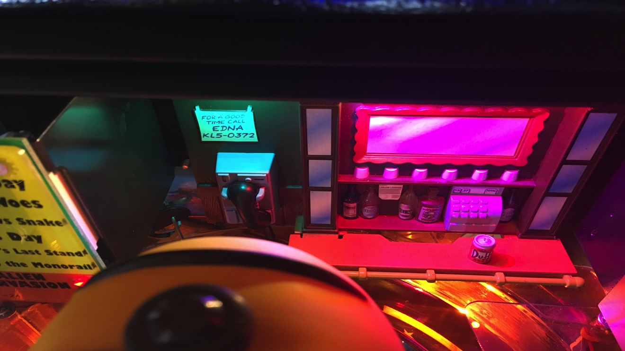

THIS IS THE BRACKET IT GOES AGAINST

1. Insert the light bulbs included and determine which lights you like where.
2. Stick your Velcro where it needs to go to contact the mod. Extra included just in case. It doesn’t take much.
3. Insert the bar

Love Meter:

1. The love meter should go over the small nut directly to the right of the small wooden bump out right next to the Bar.
2. Determine where you would like to connect or place the bulb. The wire fits nicely along side the playfield. Or you can run it through one of the holes if you like.
3. Place the bulb in one of the sockets and your meter is set to go. You can use one of the other connectors if you like as well. If you are going to put the bulb above the bar just run the wire over the backboard.

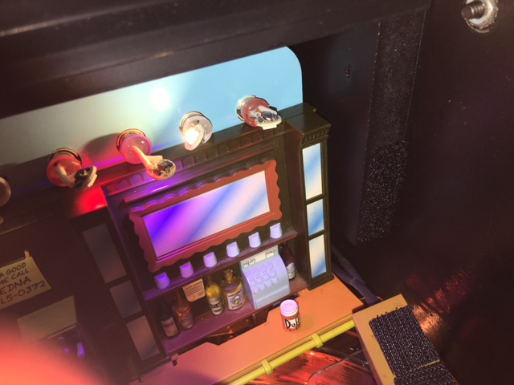

VELCRO GOES ON THE EDGE OF THIS BUMPOUT THAT IS RIGHT NEXT TO THE BAR. THE LOVE METER WILL REST RIGHT UP AGAINST IT

THE LOVE METER SHOULD GO OVER THE TOP OF THIS NUT. SNUG AGAINST THE TOP.